**Experiment-:4**

**Name:- Jayesh Mahajan**

**Roll No: - 11**

**PRN: - 1032220100**

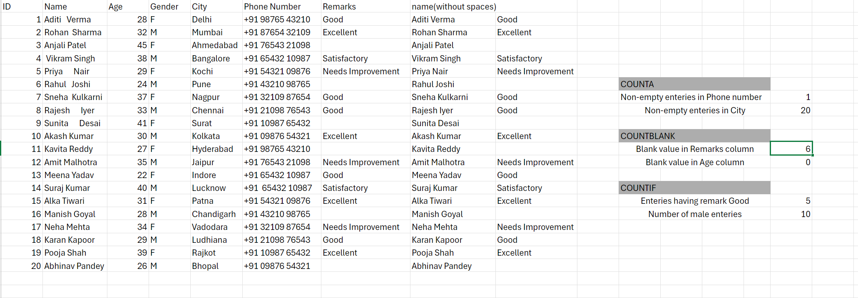

**TRIM**

**1. Question: Remove leading and trailing spaces from the names in the names in the**

**Column.**

=TRIM(B2)

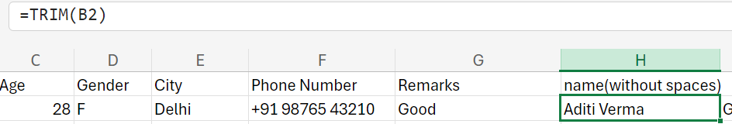

**2. Question: Clean up the "Remarks" column by removing any extra spaces that may**

**have been accidentally added.**

=TRIM(G2)

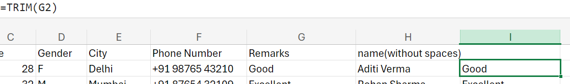

**COUNTA**

**1. Question: Count the total number of entries in the "City"column that are not empty.**

=COUNTA(E2:E21)



**COUNTBLANK**

**1. Question: How many entries have blank values in the "Remarks” column?**

=COUNTBLANK(G2:G21)

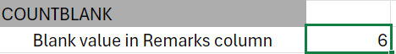

**2. Question: Count the number of blank values in the "Age" column.**

=COUNTBLANK(C2:C21)

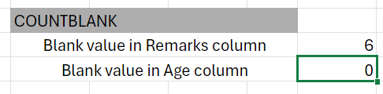

COUNTIF

1. Question: How many entries have the remark "Good”

=COUNTIF(G2:G21,"Good")

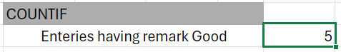

2. Question: Count the number of male entries (Gender = M) in the dataset.

=COUNTIF(D2:D21,"M")